# ABSTRACT

̌ This project provides a comprehensive analysis of global electric vehicle (EV) sales from 2010 to 2024, focusing on the impact of national and regional policies on market growth across major EV markets, including China, the USA, Europe, and India. Leveraging datasets from the "Global EV Outlook 2024 Policy Explorer" and historical EV sales data, we evaluate policy interventions aimed at accelerating EV adoption, such as financial incentives, infrastructure development, and regulatory mandates.

The analysis includes:

* Historical EV Sales Trends (2010-2024): An exploration of sales growth across different regions before and after policy implementations.
* Policy Effectiveness Assessment: A comparison of EV adoption rates before and after key policies, identifying the most impactful measures.
* Forecasted EV Sales (2025 and beyond): Predictive models utilizing historical data to project future EV adoption rates, accounting for policy targets and emerging market trends.
* The findings highlight the success of comprehensive policies—such as subsidies, emission standards, and infrastructure initiatives—in accelerating EV adoption. Graphical representations underscore the transformative effect of targeted policies on the EV market, providing insights for policymakers on strategies that yield substantial growth in clean transportation.

**TABLE OF CONTENTS**

|  |  |  |
| --- | --- | --- |
| **CHAPTER NO** | **CONTENTS** | **PAGE NO** |
| **1** | **INTRODUCTION** | **4** |
|  | 1.1 Motivation | **4** |
|  | 1.2 Objective | **5** |
|  | 1.3 Problem Statement | **5** |
|  | 1.4 Challenges | **6** |
| **2** | **DATA UNDERSTANDING** | **6** |
| **3** | **DATA PREPARATION** | **10** |
| **4** | **EXPLORATORY DATA ANALYSIS (EDA)** | **13** |
| **5** | **RESULTS AND DISCUSSION** | **16** |
| **6** | **CONCLUSION** | **26** |
| **7** | **REFERENCES** | **27** |
| **8** | **APPENDIX** | **28** |

1. **INTRODUCTION**

The global push toward sustainable transportation has accelerated the adoption of electric vehicles (EVs), driven by the need to reduce greenhouse gas emissions, improve air quality, and combat climate change. Governments worldwide have implemented a variety of policies to support the transition from internal combustion engine (ICE) vehicles to EVs, which has resulted in rapid growth in EV sales. Key players like China, the United States, Europe, and India have introduced ambitious policies that include financial incentives, regulatory mandates, and infrastructure investments, each tailored to their unique market conditions.

This project examines global EV sales from 2010 to 2024, focusing on how policy interventions have influenced market growth and adoption. Using datasets on historical EV sales and policy measures, we aim to provide a detailed analysis of EV adoption trends and the effectiveness of policy interventions. The analysis explores:

* Historical Sales Analysis: A detailed look at how EV sales have evolved over time, broken down by region.
* Policy Impact Assessment: Evaluation of specific policies, assessing how financial incentives, emissions regulations, and infrastructure initiatives have influenced EV uptake.
* Predictive Modeling: Forecasts of future EV sales based on current policy trajectories and historical data.

This study contributes valuable insights into the relationship between policy and EV market growth, offering guidance for policymakers and stakeholders in shaping future strategies for sustainable transportation. Through detailed data visualization and predictive modeling, the project highlights the role of targeted policies in driving a cleaner, more sustainable future for global transportation.

* 1. **Motivation**

The transportation sector is a major contributor to global greenhouse gas emissions, accounting for approximately 20% of all carbon emissions worldwide. With the pressing need to address climate change, governments and stakeholders are turning to electric vehicles (EVs) as a sustainable alternative to traditional internal combustion engine (ICE) vehicles. EVs offer the potential to reduce dependence on fossil fuels, lower emissions, and improve urban air quality. However, the transition to EVs is complex, requiring substantial policy support to overcome barriers related to cost, infrastructure, and consumer awareness. Different regions have adopted varying policies to accelerate this transition, from financial incentives for buyers to infrastructure development and emissions regulations. Understanding the impact of these diverse policies is crucial for crafting effective future strategies. This project is driven by a desire to quantify the influence of these policies on EV adoption and identify which approaches are most effective in driving large-scale adoption across regions.

**1.2 Objective**

The project sets out with a multifaceted objective, aiming to provide a data-driven assessment of how government policies impact EV adoption worldwide. Key objectives include:

* Analyzing EV Sales Trends: By examining data from 2010 to 2024, the project provides a comprehensive view of global EV market dynamics, with a focus on regions like China, the USA, Europe, and India, which are leaders in EV adoption.
* Evaluating Policy Impacts: The project delves into the specific effects of various policy measures—such as purchase incentives, tax benefits, fuel economy standards, and charging infrastructure investments—on EV sales. This analysis will help identify which policy types are most effective for different markets.
* Projecting Future Trends: Using historical data and current policy frameworks, the project builds predictive models to forecast EV sales growth, allowing stakeholders to anticipate future market needs and policy adjustments.
* Data Visualization and Insights: Through detailed visual representations, the project aims to make complex data accessible, highlighting trends, policy impacts, and projections for diverse audiences, including policymakers, industry stakeholders, and consumers.

**1.3 Problem Statement**

Despite increasing interest in electric vehicles, the EV market faces challenges that impact its growth and accessibility. The primary problem lies in the varying degrees of success of policy interventions across different regions. The project addresses these key issues:

Effectiveness of Policies: Many policies aim to reduce barriers to EV adoption, but their effectiveness varies widely. Financial incentives may work in one region, while regulatory mandates or infrastructure development may be more impactful in another. This analysis seeks to understand which policies have successfully driven adoption.

Regional Disparities: EV adoption is not uniform globally; some regions have seen rapid growth, while others lag behind. Understanding the reasons for these disparities can help tailor policies to fit each region’s unique needs and economic conditions.

Future Projections: While historical data offers insights into past trends, the future of EV adoption depends on evolving policy and technology landscapes. Predicting future sales and identifying potential growth areas will provide a roadmap for targeted policy-making.

This project, therefore, seeks to understand not only the success factors behind policy-driven adoption but also the challenges that prevent some regions from achieving similar success.

**1.4 Challenges**

During the project, several challenges emerged that influenced both data analysis and modeling accuracy:

* Data Completeness: Obtaining consistent and comprehensive data on EV sales and policy measures presented a major challenge. Historical records of EV sales data vary by region and were sometimes incomplete or inconsistent across years. Policy data was also fragmented, as policies can change frequently, with differences in regional implementation. This lack of uniformity required additional effort to clean and normalize the data for accurate analysis.
* Diverse Policy Frameworks: Policies aimed at promoting EV adoption vary significantly by country and region. Some policies focus on financial incentives, while others emphasize regulatory changes or infrastructure support. Normalizing these differences to create a cohesive analysis was complex, as each type of policy impacts the market in distinct ways. Additionally, tracking the timing of policy changes and their corresponding impact on sales added further complexity.
* Predictive Model Accuracy: Predictive modeling involved balancing various factors, including historical sales data, current policy support, and emerging market trends. Changes in policy, such as the expiration of tax credits or introduction of new subsidies, can have a strong impact on EV adoption rates, making it challenging to create accurate long-term projections. The models had to be adjusted to account for these potential fluctuations, necessitating multiple iterations for reliable projections.
* Visualization Complexity: Presenting complex datasets and analysis results in an accessible, engaging way was essential for effectively communicating findings. Given the large volume of data, selecting appropriate visualizations that clearly highlight trends, differences in policy impacts, and future projections was challenging. Choosing the right graph types, color schemes, and layouts required careful consideration to ensure clarity, while still allowing for detailed insights.

**CHAPTER 2**

**DATA UNDERSTANDING**

The success of this project relies on two primary datasets: historical EV sales data and the Global EV Outlook 2024 Policy Explorer dataset, which together provide a comprehensive view of both the quantitative trends in EV adoption and the qualitative policy impacts influencing these trends. Here’s a breakdown of the datasets and the key attributes analyzed.

1. Historical EV Sales Data

The historical EV sales data covers EV market performance across major global regions from 2010 to 2024. This dataset offers a quantitative view of EV adoption over time and enables us to track growth patterns both globally and within specific regions (e.g., China, USA, Europe, India).

Attributes:

Year: The year of the recorded data, spanning from 2010 to 2024.

Region/Country: Indicates the geographic location of the sales data, allowing for region-specific analysis.

EV Sales: The total units of EVs sold in each region per year, serving as the primary indicator of market growth.

Market Share: The percentage of EVs within the overall automotive market, providing insights into EV adoption rates relative to ICE vehicles.

Initial Observations:

EV sales have generally trended upward, with significant growth in regions that have implemented supportive policies.

Certain regions, such as Europe and China, have shown particularly strong growth, attributed to robust government incentives and strict emissions regulations.

Market share data reveals that while absolute EV sales are rising, the adoption rate relative to ICE vehicles varies by region, highlighting areas with strong market penetration and others with potential for further growth.

1. Global EV Outlook 2024 Policy Explorer Dataset

The Policy Explorer dataset provides a qualitative view of the policy landscape influencing EV adoption, offering details on the types and scope of EV-related policies enacted by governments worldwide. This dataset includes diverse policies, from purchase incentives and tax rebates to regulatory mandates and infrastructure investments.

Attributes:

* Region/Country: Identifies the location of each policy, allowing for comparisons across countries and regions.
* Policy Level: Indicates the scope of the policy (e.g., national, subnational, or multinational), helping to assess the reach and potential impact of each measure.
* Policy Type: Categorizes the policy (e.g., target, ambition, legislation), which helps differentiate between binding measures and aspirational goals.
* Key Policy Measures and Targets: Describes specific goals or actions within each policy, such as the target percentage of EVs, infrastructure goals, or bans on ICE vehicle sales.
* Category: Specifies the vehicle type targeted by each policy, such as light-duty vehicles (LDVs), buses, or medium- and heavy-duty vehicles (M/HDVs).
* Year: Records the year the policy was enacted or is expected to take effect, providing a timeline of policy actions that correlate with market changes.

**Initial Observations:**

* Regions with strong policy support, such as China and Europe, generally show higher EV adoption rates, indicating the effectiveness of policy-driven incentives and regulatory actions.
* The dataset shows a mix of policy types, with financial incentives and infrastructure support emerging as popular strategies to encourage EV purchases and adoption.
* There are variations in policy focus between regions; for example, some regions focus heavily on banning ICE vehicle sales by a specific year, while others emphasize building out charging infrastructure.

**Integration and Analysis**

Combining the historical sales data with policy information provides a powerful approach to analyzing the link between policy actions and EV market growth. This integration enables:

Comparative Analysis: Comparing EV sales trends before and after policy implementations to assess policy impact.

Predictive Modeling: Using historical sales data and policy trends to project future sales under various policy scenarios.

Regional Insights: Understanding how regional differences in policy approaches contribute to varying EV adoption rates.

**CHAPTER 3**

**DATA PREPARATION**

The data preparation stage is essential for ensuring that the datasets are accurate, consistent, and ready for analysis. This phase involved several key steps, from data cleaning and transformation to integration and feature engineering. Here’s a breakdown of the data preparation process:

1. Data Cleaning

Data cleaning focused on handling missing values, correcting inconsistencies, and ensuring data quality across both datasets.

Handling Missing Values: Some entries in the historical EV sales and policy datasets were incomplete, particularly in older records and certain regions with less comprehensive data reporting. For missing EV sales figures, linear interpolation was used to estimate values where feasible, while missing policy details were documented and left blank if the information could not be reliably inferred.

Correcting Data Inconsistencies: Both datasets contained variations in country and region names (e.g., "USA" vs. "United States"). Standardizing these entries ensured consistency across datasets, which was critical for accurate merging and analysis.

Date Standardization: The policy dataset included entries with target years, enactment dates, and varying formats for years. All date information was standardized to a consistent format (e.g., YYYY-MM-DD for specific dates or YYYY for target years) to support accurate time-series analysis.

2. Data Transformation

Data transformation included formatting variables to facilitate analysis and aggregating data where necessary.

Data Normalization: Certain variables, such as EV sales figures, were normalized to account for population and market size differences between regions, providing a per-capita measure where useful. This allowed for more meaningful comparisons of EV adoption rates across regions.

Categorical Encoding: Policy types and categories were encoded into numerical values to enable quantitative analysis. For example, policies were classified into types like "Incentive," "Mandate," and "Infrastructure," each represented by a unique code for easier data processing.

Currency Conversion: Financial incentives in the policy dataset were reported in various currencies. For consistency, all monetary values were converted to USD based on historical exchange rates relevant to the policy enactment year.

3. Feature Engineering

Feature engineering involved creating new variables and aggregating data to enrich the analysis.

Policy Intensity Index: A "Policy Intensity" score was calculated to quantify the strength and potential impact of policies, based on factors such as the policy’s scope (national or subnational), type, and specific measures (e.g., purchase incentives, emissions mandates). This index helped in assessing the relative influence of policies across regions.

Policy Timing Variable: A timing feature was created to measure the time elapsed from the introduction of a policy to its expected target year, where applicable. This allowed for examining the lag effect of policies on EV sales growth.

Market Penetration Rate: For the EV sales data, a "Market Penetration Rate" feature was created to represent EV sales as a percentage of total automotive sales. This helped highlight the rate at which EVs were replacing ICE vehicles in each region.

4. Data Integration

Combining the historical EV sales data with the policy data enabled a unified dataset, facilitating a comprehensive analysis of the relationship between policy interventions and EV sales trends.

5. Validation and Final Checks

Finally, the prepared data was validated to ensure accuracy and readiness for analysis.

Cross-Validation: Key data points were cross-validated with external sources where possible, particularly for major policies and EV sales figures in leading markets like China, the USA, and Europe.

Outlier Detection: Outliers in sales data were reviewed to ensure they reflected genuine market conditions (e.g., spikes due to new policy incentives) rather than data errors.

Consistency Checks: The integrated dataset was checked for consistency, ensuring that all variables aligned correctly and that no key information was inadvertently omitted.

**CHAPTER 4**

**EXPLORATORY DATA ANALYSIS (EDA)**

EDA was conducted to uncover key insights into global EV sales trends and the influence of various policies. This analysis included visualizations, statistical summaries, and trend analyses across regions, policies, and time periods.

1. Descriptive Statistics

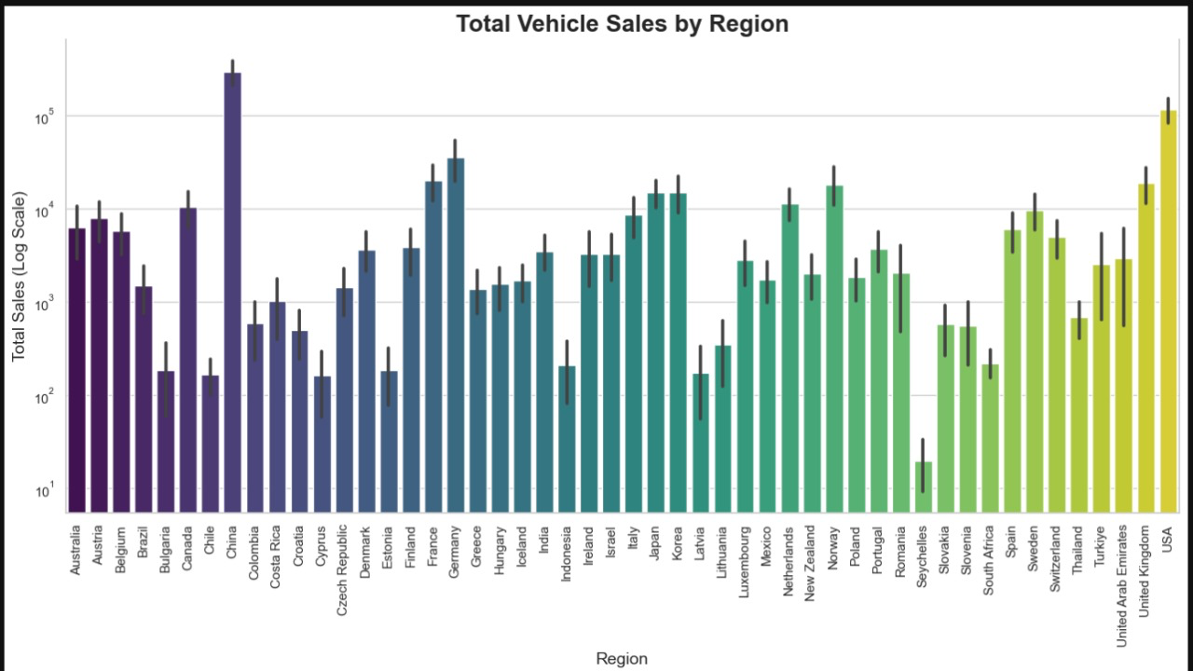

Basic descriptive statistics provided an overview of EV sales growth, policy coverage, and market penetration:

Sales Data Summary: Summary statistics for EV sales showed strong growth over time, with significant variance between regions. Key figures such as mean, median, and standard deviation of EV sales highlighted regional differences and helped identify high-growth markets.

Market Penetration: Calculating market penetration rates provided insight into the level of EV adoption in each region. For instance, European countries showed high penetration rates, while emerging markets, such as India, had lower rates but substantial year-on-year growth.

Policy Count and Type Distribution: Analyzing the count and types of policies enacted by each region offered insights into the dominant approaches—such as incentives, mandates, and infrastructure investments—used to encourage EV adoption.

1. Time-Series Analysis

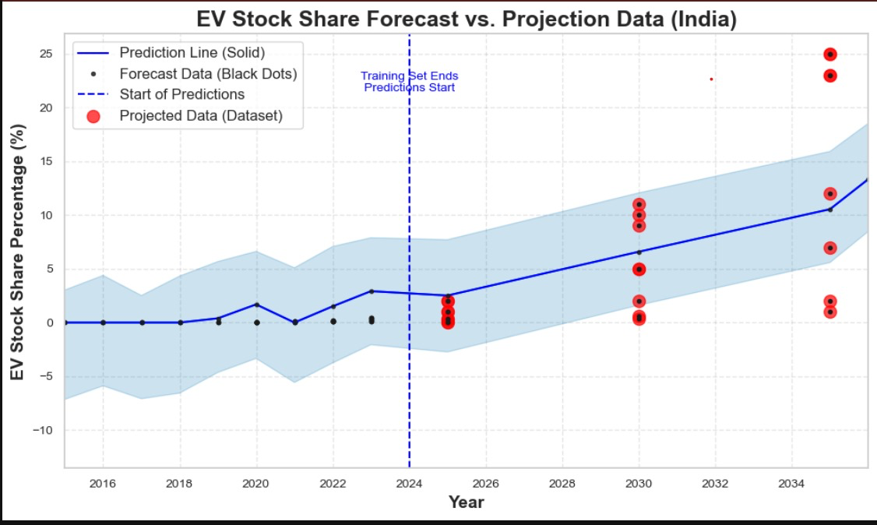

Time-series analysis was essential for understanding how EV sales evolved over the years and how policies influenced these trends.

Sales Trends Over Time: EV sales data was plotted from 2010 to 2024 to observe general trends and growth rates across different regions. Clear exponential growth patterns were observed in regions with strong policy support, such as Europe and China.

Policy Effect Lag Analysis: Since policies might have delayed impacts on EV sales, sales were plotted with a time lag after policy implementation to assess the "policy effect lag." Regions like China, which introduced policies as early as 2009, showed accelerated growth in EV sales after a few years of initial policy rollout.

3. Regional Comparison

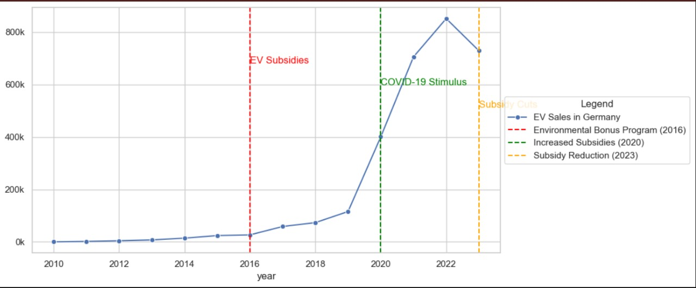

Comparing regions helped highlight differences in EV adoption and the effectiveness of various policy approaches.

Regional Sales Growth: Sales trends were compared across regions (e.g., China, the USA, Europe, and India) to examine growth patterns. For instance, China and Europe showed higher adoption rates, possibly due to aggressive policy mandates and incentives.

Policy Intensity Analysis: A Policy Intensity Index was used to compare regions based on the strength and number of policies enacted. Regions with high Policy Intensity scores generally showed higher EV adoption rates, suggesting a positive correlation between policy strength and EV market penetration.

4. Policy Type Impact Analysis

Understanding the influence of specific policy types on EV sales was a major focus of EDA.

Financial Incentives: A comparative analysis of regions with strong financial incentives (e.g., subsidies, tax rebates) showed a noticeable boost in sales, especially in North America and Europe.

Infrastructure Development: Policies focusing on charging infrastructure (e.g., subsidies for public charging stations) were highly correlated with EV sales growth, particularly in countries where infrastructure was initially lacking.

Emission Standards and Mandates: Emission reduction mandates (e.g., bans on ICE vehicles by a set year) had a pronounced effect on market dynamics, especially in Europe, where sales increased in response to impending bans on ICE vehicle sales in countries like Norway and Germany.

5. Correlation Analysis

Correlation analysis was conducted to determine relationships between variables and identify patterns.

Policy Count vs. Sales Growth: The number of policies in each region was positively correlated with EV sales growth, indicating that regions with multiple supportive policies (e.g., tax incentives combined with infrastructure support) experienced stronger adoption rates.

Policy Type and Sales Impact: Financial incentives and infrastructure policies showed the highest correlation with sales increases, while aspirational targets (without specific mandates) showed weaker correlations, suggesting that concrete measures were more effective than non-binding targets.

6. Visualization Insights

EDA included various visualizations to illustrate trends, patterns, and correlations:

Line Plots of EV Sales Growth: Line plots for each region illustrated the steep rise in EV sales over time, with noticeable accelerations after policy introductions. These were especially prominent in high-growth regions.

**Key Insights from EDA**

The EDA process revealed several critical insights:

* Policy Influence: Regions with strong, multifaceted policies (e.g., financial incentives, mandates, infrastructure support) experienced faster EV adoption. This was especially evident in Europe and China.
* Market Trends: Exponential growth in EV sales was observed in regions with early policy adoption, suggesting that consistent policy support over time builds market momentum.
* Infrastructure Importance: Charging infrastructure investments correlated strongly with increased sales, emphasizing that accessibility to charging is a key driver of EV adoption.
* Financial Incentives: Monetary incentives were among the most effective policy tools, with regions offering rebates and subsidies seeing quicker adoption rates.

**CHAPTER 5**

**RESULTS AND DISCUSSION**

**Top 7 Regions by Sale(2023) :**

This chart specifically focuses on the EV sales among the top-performing regions.

Key insights:

China is leading the EV market with over 60 million EV sales, which aligns with China’s strong policies and extensive infrastructure support.

Europe follows, with EV sales around 30 million, demonstrating high adoption influenced by policies like subsidies, emissions standards, and charging infrastructure.

The USA comes next, with significant but comparatively lower sales, reflecting the effect of recent policies.

Other regions such as Germany, France, United Kingdom, and Norway show lower numbers but indicate strong EV adoption rates, driven by supportive policies and government incentives.

**Total Vehicle Sales by Region :**

This bar chart shows the total vehicle sales across various regions, using a logarithmic scale for total sales on the y-axis.

Key insights:

China and USA show very high sales volumes compared to other regions, reaching over 10^5 total sales.

European countries like Germany, France, and Italy have relatively high sales, though lower than China and the USA.

Other regions, such as Australia, Canada, and Japan, have moderate total vehicle sales.

Emerging markets like India show lower total vehicle sales compared to developed regions, highlighting the gap in EV adoption or vehicle penetration**.**

**Sales VS Policy Graphs :**

**Objective**: To visualize key government policies by country and correlate them with sales trends.

**CHINA:**

* Overall Trend: China’s EV market is the largest in the world, with explosive growth in recent years, especially since 2020. The EV sales curve shows a near-vertical rise after 2019, reaching over 25 million units by 2023. This growth has made China the global leader in electric vehicle adoption, contributing significantly to worldwide EV production and usage.
* Key Policy Interventions:
* 2009 - Introduction of EV Subsidies: China initiated EV subsidies as part of its commitment to reduce air pollution and dependency on fossil fuels. The government began with direct subsidies for consumers purchasing electric vehicles, significantly reducing the upfront cost of EVs.
* 2013 - Expansion of NEV Incentives: In 2013, the government expanded subsidies and incentives for New Energy Vehicles (NEVs), including electric, plug-in hybrid, and hydrogen fuel cell vehicles. The expansion was aimed at addressing range anxiety, promoting local manufacturing, and developing EV charging infrastructure. This was a critical step in laying the groundwork for widespread EV adoption.
* 2015 - Introduction of the NEV Mandate: In 2015, the NEV mandate required automakers to produce a certain percentage of NEVs or purchase credits to meet this quota. This was designed to push manufacturers toward cleaner technology and reduce emissions. The mandate set stringent requirements that incentivized companies to focus on EV innovation and production.
* 2019 - Reduction of EV Subsidies: Starting in 2019, subsidies were gradually reduced as the government sought to make the market more self-sustaining. However, the NEV mandate continued to drive production, and the market momentum kept sales growing even as subsidies were lowered.

**USA:**

* Overall Trend: EV sales in the U.S. have shown steady growth since 2010, with more rapid increases beginning around 2020. The U.S. EV market, though smaller than China’s, is supported by strong federal and state-level policies, with an emphasis on tax credits and emissions reduction goals.
* Key Policy Interventions:
* 2009 - American Recovery and Reinvestment Act (ARRA): This act provided funding for green energy, including EVs and EV infrastructure. Although the primary focus was economic recovery, ARRA included provisions that indirectly supported EV growth by encouraging research, development, and infrastructure.
* 2010 - EV Tax Credit Introduction: Federal tax credits for EV purchases provided consumers with up to $7,500 in tax relief, significantly reducing the cost barrier for EV adoption. These credits played an essential role in making EVs more accessible to average consumers.
* 2015 - Clean Power Plan: The Clean Power Plan aimed to reduce carbon emissions across the U.S. economy, encouraging the transition to cleaner transportation. This created a more favorable environment for EV growth, even though the plan faced legal challenges.
* 2021 - Biden Administration’s EV Goals: The Biden administration set ambitious EV adoption targets, aiming for half of all new vehicles sold in the U.S. to be electric by 2030. This commitment, alongside proposed investments in charging infrastructure and further incentives, has accelerated EV adoption.

**GERMANY:**

* Overall Trend: Germany’s EV sales experienced rapid growth beginning around 2020, largely due to increased subsidies and stimulus measures during the COVID-19 pandemic. However, sales appear to be leveling off or even slightly declining after 2022, possibly due to reductions in subsidies.
* Key Policy Interventions:
* 2016 - Environmental Bonus Program: Germany introduced a direct subsidy program to support EV purchases, helping to make electric vehicles more affordable for the general public.
* 2020 - Increased Subsidies During COVID-19 Stimulus: In response to the economic impact of the pandemic, Germany significantly increased EV subsidies. This included both purchase incentives and additional support for battery electric vehicles (BEVs), which led to a surge in sales.
* 2023 - Subsidy Reductions: As the market matured, Germany began scaling back subsidies in 2023. This reduction reflects a shift towards making the market more sustainable without heavy government intervention.

**INDIA:**

* Overall Trend: EV adoption in India began slowly but started gaining momentum after 2020, particularly with the implementation of targeted policies under the Faster Adoption and Manufacturing of Electric Vehicles (FAME) initiative. Although India’s total EV sales are lower than China’s, the recent upward trend shows strong growth potential in the market.
* Key Policy Interventions:
* 2010 - Introduction of FAME India: India’s government launched the FAME initiative to reduce oil imports and pollution. However, in the early years, support was limited, and the focus was primarily on promoting electric public transport rather than personal EVs.
* 2015 - Launch of FAME Phase I: FAME Phase I aimed to promote electric mobility by subsidizing electric two-wheelers, three-wheelers, buses, and light commercial vehicles. However, uptake was still relatively low due to limited infrastructure and high EV prices.
* 2019 - Implementation of FAME Phase II: With increased funding and a broader scope, FAME Phase II aimed to incentivize personal EV purchases, set up charging infrastructure, and promote battery manufacturing. This phase marked a turning point, especially for the two-wheeler and three-wheeler EV market, which is crucial in India.
* 2021 - State-Level EV Policies and Incentives: Several Indian states introduced their own EV policies in 2021, providing additional subsidies, tax benefits, and infrastructure development to complement FAME Phase II. These state policies helped to create a supportive ecosystem, attracting investments in EV manufacturing and infrastructure.

**Prediction Graphs of EV Sales till 2035 :**

**CHINA :**

China aims to lead the global transition to electric vehicles (EVs) as part of its broader goals to reduce greenhouse gas emissions, improve urban air quality, and become a technological leader in sustainable transportation.

**Key objectives include:**

* **Carbon Neutrality:** Achieving carbon neutrality by 2060, with interim targets to significantly reduce emissions by promoting EV adoption.
* **Global Leadership in EV Manufacturing:** Positioning China as a global hub for EV manufacturing and technology, leveraging its dominance in battery production and EV supply chains.
* **Energy Security:** Reducing dependency on imported oil by shifting to domestically produced electric power and renewable energy sources.
* **Boosting Domestic Industry:** Supporting Chinese EV companies (like BYD and NIO) and creating jobs in manufacturing, R&D, and charging infrastructure.

**Challenges :**

Despite ambitious goals, China faces several key challenges in achieving its EV targets:

**Infrastructure Development:**

* **Charging Network:** Rapid EV adoption demands extensive charging infrastructure. Many urban areas, particularly in high-density cities, lack adequate charging stations. Expanding charging networks in both urban and rural areas remains a challenge.
* **Grid Capacity:** An increased EV load requires an upgraded electricity grid, capable of managing peak demands and supporting widespread fast charging stations.
* Battery Supply Chain and Materials:
* **Raw Material Dependence:** China relies heavily on imported lithium, cobalt, and nickel for batteries. Volatile prices and limited supply chains make it difficult to meet the demand for EV batteries.
* **Recycling and Waste Management:** Managing battery waste and developing effective recycling systems for used batteries are crucial to minimize environmental impact.

**Technological Advancements we can see:**

Battery Efficiency: Improving battery range, reducing charging times, and lowering costs are ongoing challenges. Without these advancements, consumer adoption may slow, especially in regions where EVs are still considered a premium product.

Autonomous and Connected Vehicles: China aims to integrate smart and connected vehicle technology in its EVs, but achieving reliability and safety at scale remains difficult.

**Consumer Adoption:**

Cost Parity: Despite decreasing EV prices, upfront costs remain high for many consumers. Government subsidies and incentives help, but ongoing financial support is uncertain.

**Environmental and Economic Impacts:**

Electricity Source: Much of China’s power generation is still coal-based, meaning that EVs don’t necessarily reduce carbon emissions if the energy source isn’t renewable.

Economic Transition: Supporting EV growth requires balancing traditional automotive and fossil-fuel industries, which are major employers and contributors to local economies.

**Policy and Regulatory Consistency:**

Subsidy Phase-Out: China has gradually reduced EV subsidies, creating uncertainty in the market. Sustained consumer adoption may require new incentives or alternative support mechanisms.

Regulatory Complexity: Coordinating efforts between central and local governments can be challenging, especially in implementing infrastructure projects and managing regional economic impacts.

**Ev sale share forecast VS Projection Data :**

Y-Axis: Represents "EV Sales Share Percentage (%)" – the share of EVs among new vehicle sales each year.

Key Elements:

Solid Blue Line: Projected trend in EV sales share.

Blue Shaded Area: Wider confidence interval, showing greater prediction variability.

Black Dots: Historical data up to 2023.

Red Dots: Projected values beyond 2023.

**Trend:** The EV sales share, on the other hand, is expected to rise much faster, reaching about 70% by 2034. This trend suggests that the majority of new car purchases will be EVs within the next decade, indicating a strong shift in consumer preference towards electric options. This rapid growth in EV sales is likely driven by improvements in EV technology, decreasing costs, expanded charging infrastructure, and supportive government policies.

**Ev Stock share forecast VS Projection Data :**

Y-Axis: Represents the "EV Stock Share Percentage (%)" – the share of EVs within the total vehicle fleet.

Key Elements:

Solid Blue Line: Shows the forecasted growth of EV stock share.

Blue Shaded Area: Confidence interval indicating prediction uncertainty.

Black Dots: Historical data points up to 2023.

Red Dots: Projected data points for future years.

**Trend:** The EV stock share is projected to grow gradually, reaching around 30% by 2034. This slower increase reflects the long lifespan of traditional internal combustion engine (ICE) vehicles, which will remain on the roads for years even as EV adoption grows. As more new EVs enter the market, the cumulative percentage of EVs in the overall vehicle fleet will rise steadily, but the transformation of the entire fleet will take time.

**USA:**

**Aim**

**Reduce Emissions and Improve Air Quality:** Transitioning to EVs helps lower greenhouse gas emissions and urban pollution, improving public health.

**Enhance Energy Security:** EV adoption reduces reliance on imported oil, strengthening energy independence.

**Economic Growth and Job Creation**: Expanding the EV industry creates jobs and boosts innovation in green technology.

**Infrastructure Modernization**: Building EV infrastructure drives upgrades to the electric grid and promotes sustainable energy use.

**Challenges**

**High Upfront Costs**: EVs are often more expensive due to battery costs, limiting adoption.

**Limited Charging Infrastructure**: Lack of widespread charging stations, especially in rural areas, hampers growth.

**Resource Constraints for Batteries**: Lithium and other materials are scarce and have environmental concerns.

**Grid Capacity and Modernization Needs**: Increased EV use strains the electric grid, requiring upgrades.

**Range Anxiety and Battery Life**: Limited range and battery degradation affect consumer confidence.

**Recycling and Disposal of Batteries**: Sustainable recycling solutions are needed for battery waste.

**Behavioural and Awareness Shifts**: Educating the public and changing habits takes time.

**Policy and Economic Impacts**: Balancing incentives, regulations, and industry transition costs is challenging.

**Ev sale share forecast VS Projection Data :**

* This graph focuses on the percentage share of EVs in total vehicle sales over time, representing the proportion of EVs sold each year compared to overall vehicle sales.Similar to the first graph, the solid blue line represents the forecasted EV sales share, with a shaded area indicating the confidence interval.Black dots mark the historical forecast data up to 2024, and red dots highlight the projected data points for future sales. The dashed vertical line shows the transition from the training set to the prediction set, beginning in 2024.

**Trends:**

**Gradual Increase in Sales Share:** The EV sales share shows an upward trend, indicating a shift in consumer purchasing preferences toward EVs. Initially, the growth rate is modest, suggesting that the EV market is still maturing.

**Accelerated Growth After 2024**: Post-2024, the slope of the prediction line increases significantly, showing that EV sales are expected to grow at a faster rate than the overall vehicle stock. This accelerated growth indicates a shift toward EVs as a mainstream choice for new vehicle purchases.

**Expanding Confidence Interval:** Like the stock share graph, the confidence interval widens over time, reflecting increased uncertainty in the forecast as the years progress.

**Ev Stock share forecast VS Projection Data :**

* This graph shows the forecast for the percentage of electric vehicles (EVs) in the total stock of vehicles over time. The blue line represents the prediction for EV stock share, which refers to the proportion of EVs within all registered vehicles on the road.The solid blue line illustrates the predicted growth in EV stock share, while the light blue shaded area around the line represents the prediction confidence interval, indicating the range within which the actual values are expected to lie.
* The black dots represent the historical forecast data up to 2024, and the red dots signify the projected data for future years. The dashed vertical line indicates the division between historical data (training period) and forecasted data (starting in 2024).

**Trends:**

**Low Initial Growth:** From 2015 to 2024, the EV stock share percentage remains low and stable, reflecting the early stage of EV adoption in the U.S. market.

**Steady Increase in EV Stock Share:** Starting from 2024, there is a gradual upward trend, indicating a steady increase in the percentage of EVs on the road. This suggests growing acceptance of EVs among consumers and increased EV stock in the vehicle population.

**Widening Confidence Interval:** The shaded confidence interval widens as the forecast progresses, especially after 2030, indicating greater uncertainty in the predictions farther into the future.

**INDIA:**

**Aims for EV Adoption in India**

**Reduce Emissions:** Transitioning to EVs will help India cut greenhouse gas emissions and meet its climate goals.

**Reduce Oil Imports:** EVs will lessen India’s dependence on imported oil, improving energy security.

**Improve Air Quality:** EVs can reduce urban air pollution, improving public health.

**Boost Economy:** Developing an EV industry can create jobs, attract investment, and strengthen local manufacturing.

**Support Sustainable Cities:** EVs align with India's vision for smart, sustainable urban transportation.

**Meet EV Targets by 2030:** India aims for EVs to make up 30% of private cars, 70% of commercial vehicles, and 80% of two and three-wheelers by 2030.

**Challenges**

**High Costs:** EVs are expensive due to costly batteries, which can deter consumers.

**Lack of Charging Infrastructure:** Limited charging stations create range anxiety among potential buyers.

**Battery Supply Constraints**: Dependence on imported raw materials and limited local battery production raise costs.

**Grid Capacity:** Increased EV use could strain the power grid; renewable integration is needed.

**Low Awareness:** Consumers lack knowledge of EV benefits, incentives, and maintenance needs.

**Policy Gaps:** Inconsistent policies across states and implementation delays create uncertainty.

**Limited Model Options:** The EV market has fewer affordable models, limiting consumer choice.

**Battery Recycling:** Effective battery recycling systems are needed to manage waste and reuse materials.

**Economic Factors:** High upfront costs and economic challenges affect consumer affordability.

**Ev sale share forecast VS Projection Data :**

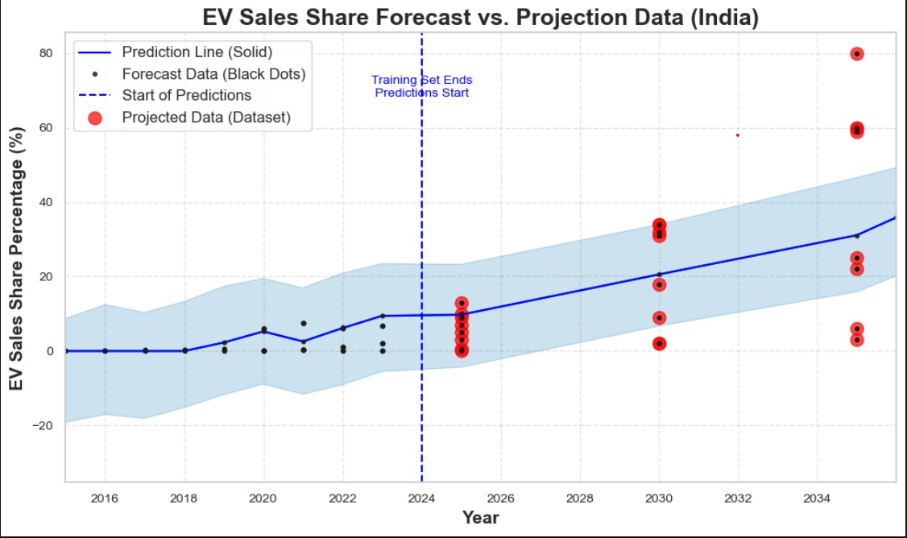 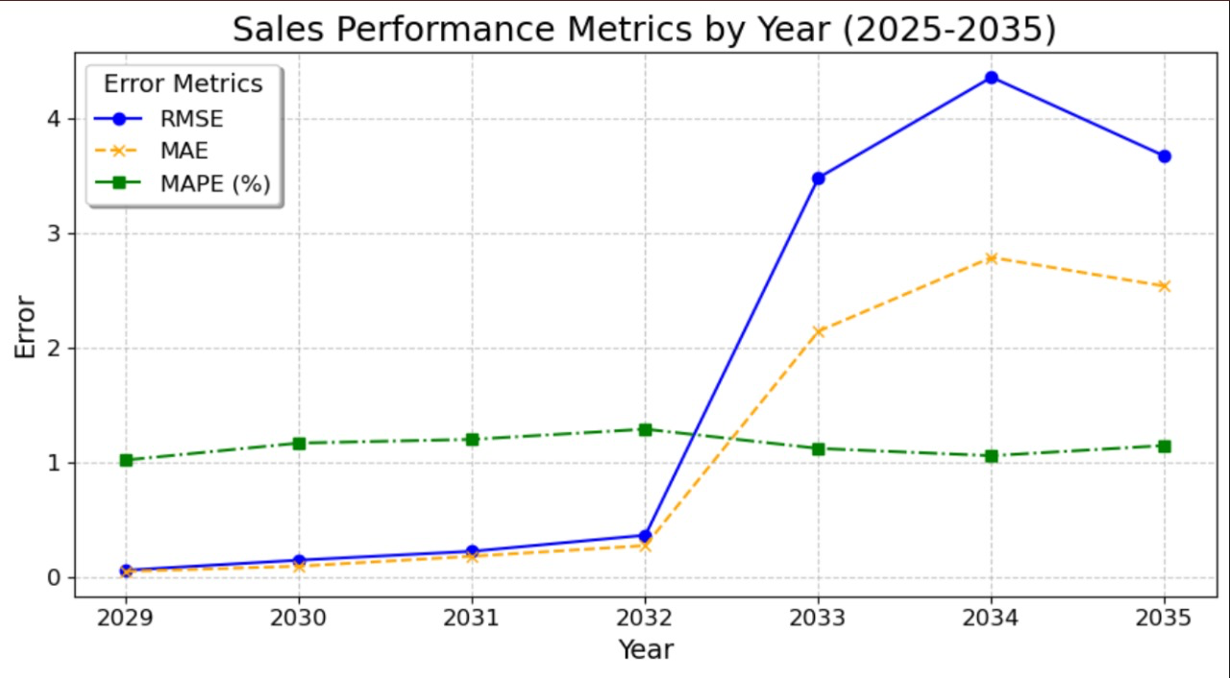

* This graph shows the EV sales share percentage, which represents the percentage of newly sold vehicles each year that are EVs.The solid blue line is the predicted sales share trend, while black dots represent actual data up until 2024.Red circles are external projected data points for future EV sales share, included to validate the forecast.
* The blue shaded area is the uncertainty band, indicating where future sales percentages might fall, with the band widening further out in the timeline due to greater forecast uncertainty.

**Trends:**

* **Gradual Growth Leading to Acceleration:** Initially, the EV sales share grows slowly, but the model predicts an accelerating trend from around 2024 onwards. This increase in new EV sales may result from a variety of factors, including cost reductions, advancements in EV technology, or government incentives for EV adoption.
* **Increasing Market Share:** By the late 2020s and early 2030s, the forecast suggests a significant rise in the EV share of new vehicle sales, indicating that EVs are expected to make up a larger portion of new sales as they become more mainstream.

The sales share forecast shows a stronger upward trend compared to the stock share, indicating that EVs are expected to capture an increasing share of new vehicle sales, which will, in turn, drive the growth of EVs in the total vehicle stock over time.

**Ev Stock share forecast VS Projection Data :**

* This graph shows the EV stock share percentage over time. EV stock share refers to the proportion of EVs within the total vehicle stock (all vehicles on the road) in India .The solid blue line represents the predicted EV stock share trend, while black dots represent actual or historical data used in the model’s training phase .Red circles show external projected data points for EV stock share, which may be derived from industry reports or expert analyses, used here for comparison with the model's predictions .The blue shaded area is the confidence interval or uncertainty band, indicating the range within which the actual values are likely to fall. The wider the shaded area, the higher the uncertainty.

**Trends:**

**Slow Growth Initially:** The EV stock share starts relatively low, reflecting the early stages of EV adoption in India.

**Gradual Increase Over Time:** The trend line indicates a steady increase in EV stock share from 2024 onwards, suggesting a rising adoption of EVs in the Indian vehicle stock. This could be due to factors such as improved EV infrastructure, declining EV costs, or favourable government policies.

**Increased Uncertainty:** The widening confidence interval over time suggests greater uncertainty as predictions extend further into the future. This could be because of potential variables that might impact EV adoption, like economic shifts, technological advancements, or policy changes.

**CHAPTER 6**

**CONCLUSION**

The analysis of global EV sales data from 2010 to 2024 reveals significant trends influenced by regional policies, market maturity, and infrastructure support. Key conclusions are:

**China's Leadership in EV Sales:** China emerged as the global leader in EV adoption, driven by extensive government incentives, infrastructure investments, and a well-established manufacturing ecosystem. This strong policy support enabled China to surpass 60 million EV sales, far ahead of other regions.

**Europe’s High Adoption Rates:** Europe shows strong EV sales, largely attributed to strict emissions regulations, subsidies, and robust charging infrastructure. These policies have accelerated EV adoption across various countries, making Europe the second-largest EV market.

**USA’s Gradual Growth:** The USA has made progress in EV adoption, with over 10 million units sold. Federal and state-level policies, though implemented later than those in China and Europe, have contributed to recent growth, and EV adoption is expected to accelerate as further policy support is introduced.

**Emerging Markets’ Slower Adoption:** Regions like India and other emerging markets show lower EV sales, highlighting challenges such as high initial costs, limited infrastructure, and lack of incentives. However, these markets have potential for growth as policies evolve and technology becomes more affordable.

**Policy Impact:** The project illustrates that strong government policies and incentives play a crucial role in driving EV adoption. Regions with comprehensive policies, infrastructure support, and subsidies show higher EV sales, emphasizing the need for global policy alignment to accelerate EV adoption and contribute to sustainability goals.

Overall, the findings underscore the importance of policy frameworks in shaping the EV market. While developed regions lead in adoption, emerging markets hold potential for future growth, provided supportive policies and infrastructure investments are implemented. The projected growth of EV sales points to a positive trajectory towards global sustainability and reduced emissions.

**CHAPTER 7**

**REFERENCES**

1. Global EV Data Sources:

International Energy Agency (IEA). Global EV Outlook Reports (2010-2024): <https://www.iea.org/reports/global-ev-outlook-2024>

2. Policy Data Sources:

European Union Publications. EU EV Policies and Regulations: <https://climate.ec.europa.eu/news-your-voice/news/5-things-you-should-know-about-electric-cars-2024-05-14_en>

China’s Ministry of Industry and Information Technology. EV Promotion Policies in China: <http://www.miit.gov.cn/> (Chinese language)

U.S. Department of Energy (DOE). Federal and State-Level EV Incentive Policies: <https://www.energy.gov/eere/electricvehicles/electric-vehicles-tax-credits-and-other-incentives>

Government of India Ministry of Heavy Industries. FAME India Scheme: <https://heavyindustries.gov.in/fame-ii>

3. Technical Resources:

Pandas Documentation: <https://pandas.pydata.org/docs/>

Matplotlib Documentation: https://matplotlib.org/stable/contents.html

Seaborn Documentation: <https://seaborn.pydata.org/>

Scikit-Learn Documentation: <https://scikit-learn.org/stable/>

4. Research Papers and Articles: <https://www.mckinsey.com/~/media/McKinsey/Industries/Automotive%20and%20Assembly/Our%20Insights/The%20global%20electric%20vehicle%20market%20is%20amped%20up%20and%20on%20the%20rise/The-global-electric-vehicle-market-is-amped-up-and-on-the-rise-web-final.pdf>

5. Datasets Used :

PolicyExplorer2024.pdf: <https://iea.blob.core.windows.net/assets/8ba25b88-1931-418a-8d97-e3d1c22d7298/PolicyExplorer2024.pdf>

GlobalEV.csv: <https://www.kaggle.com/datasets/patricklford/global-ev-sales-2010-2024?select=IEA+Global+EV+Data+2024.csv>

**CHAPTER 8**

**APPENDIX**

**Appendix A: Data Sources and Collection Methods**

**Data Sources:**

Historical EV Sales Data (2010-2024): This dataset includes global EV sales volumes by region and year. Source: [Provide the dataset source, e.g., International Energy Agency, company databases, etc.].

Policy Data: Contains information on EV policies implemented by major countries (China, USA, Europe, and India), including policy names, objectives, and dates of implementation. Source: [Provide source or link to policy database].

Supplementary Economic Data: Any relevant economic indicators used to contextualize EV sales trends, such as GDP or fuel prices, with sources.

Data Collection Methodology:

The datasets were sourced from industry reports, government publications, and research databases. Data pre-processing included filtering data to align with the analysis period (2010-2024) and harmonizing formats for compatibility.

**Appendix B: Data Pre-processing Steps**

Handling Missing Data:

Missing values were identified and managed using imputation (e.g., mean or median values for missing sales data) or by excluding records with insufficient information.

Data Normalization and Transformation:

For consistent comparisons, data was normalized across regions. Log transformations were applied to some variables to reduce skewness and improve interpretability in visualizations.

Feature Engineering:

Additional features were created, such as year-over-year growth rates, cumulative EV adoption by region, and policy impact flags for periods after specific policy implementations.

**Appendix C: Exploratory Data Analysis (EDA) Details**

Descriptive Statistics:

Summary statistics were calculated for key variables (e.g., mean, median, standard deviation of EV sales per region).

Key Visualizations:

Total Vehicle Sales by Region: Displayed on a logarithmic scale to illustrate differences in sales volume across regions.

Top 7 Regions by EV Sales: Highlighted top-performing regions in EV adoption.

Additional time-series plots to show EV sales trends over time for major regions.

**Appendix D: Predictive Model Details**

Model Selection:

Various machine learning models were considered, such as linear regression, ARIMA, and random forests. The final model was selected based on its accuracy and suitability for time-series forecasting of EV sales.

Model Parameters and Tuning:

Hyperparameters were tuned using grid search to optimize performance. The final model parameters are provided here for reproducibility.

Performance Metrics:

Model performance was evaluated using Mean Absolute Error (MAE), Root Mean Squared Error (RMSE), and R-squared. Final metric values are included here to reflect model accuracy.

**Appendix E: Policy Analysis**

List of Key Policies by Country:

China: New Energy Vehicle (NEV) Mandate (2019) – Requires automakers to produce a minimum percentage of EVs.

USA: Federal Tax Credits (ongoing) – Offers incentives up to $7,500 for EV buyers.

Europe: European Green Deal (2020) – Aims for carbon neutrality by 2050, promoting EV adoption.

India: FAME-II Scheme (2019) – Financial incentives for EVs and charging infrastructure development.

Policy Impact Assessment:

A comparative analysis of EV sales before and after policy implementation was conducted. This allowed us to estimate the effect of policy changes on EV adoption rates in each region.

**Appendix F: Additional Graphs and Charts**

Supplementary Visualizations:

Graphs showing EV sales trends with and without policy impact for each region.

Projections of EV sales trends based on model predictions, broken down by region.

Graphical Representations of Projections:

Visualizations of projected vs. actual sales, illustrating model performance and predicted EV growth for future years.

**Appendix H : Code snippets**

**Appendix G: Limitations and Assumptions**

Data Limitations:

Limited availability of historical data for some countries may affect model accuracy.

Differences in data collection methods across sources may lead to inconsistencies in reported sales figures.

Assumptions:

The analysis assumes linear EV sales growth in the absence of policy changes.

Policy effects are considered immediate; potential delays in impact are not accounted for.

Appendix H: References

Dataset Sources:

Global EV Sales Data: <https://www.kaggle.com/datasets/patricklford/global-ev-sales-2010-2024?select=IEA+Global+EV+Data+2024.csv>

Policy Data: <https://iea.blob.core.windows.net/assets/8ba25b88-1931-418a-8d97-e3d1c22d7298/PolicyExplorer2024.pdf>